
Assignment Cover Sheet
Subject Code: | CSIT375
Subject Name: | AI For Cyber Security
Submission Type: | Assignment 2 Report
Assignment Title: | AI-powered Malware detection
Student Name: | Omar Al-Khaldi, Mohamad Daya , Abdallah AlBasha
Student Number: | 8061543, 7738882 , 7835085
Lecturer Name: | Dr Manoj
Due Date: | 8/11/2024
Date Submitted: | 8/11/2024

 | Contributions (100%)
Omar Al-Khaldi 8061543 | 33.3%
Mohamad Daya 7738882 | 33.3%
Abdallah AlBasha 7835085 | 33.3%

Contents
AI-Powered Malware Detection and Classification System 3
Project Background 3
Project Scope 3
Goal : 3
AI Model Development: 3
Data Source 3
Understanding Dataset 3
Dataset Limitations 4
Dataset Analysis 4
Analysis Conclusion 6
Oversampling of Benign class 7
Histogram Distribution Oversampling 8
Models used 9
Building Classifier Model 9
Independent variables 9
Independent Code Section 10
Training : Test ratio 11
Model 1 : Random Forest 11
Training 11
Testing 11
Evaluation Metrics 11
Metrics Explained 12
Classification Report 12
Confusion matrix 13
Cross-Validation Scores 14
Model 2 : Logistic Regression 17
Training 17
Testing 17
Evaluation Matrices 17
Model 3 : Gradient Boosting 18
Training 18
Testing 18
Evaluation Matrices 19
Matrix Comparison 20
Report Conclusion 23

AI-Powered Malware Detection and Classification System

Project Background
Malware can cause severe damage, including unauthorized data access, financial losses, and disruption of services. Traditional methods of malware detection often rely on signature-based techniques, which are limited in detecting new or modified malware variants.
This project aims to address these limitations by leveraging machine learning and deep learning techniques to create a model that not only identifies whether a file or network activity is malicious but also categorizes the type of malware if detected.

Project Scope
Goal : Detects and classifies malware in real-time by analysing incoming data files and network traffic.
AI Model Development: The security team has created an AI model which is binary classifier.
- Binary Classifier : Automatically classify files and network activities as malicious or benign.
- Build the Classifier using three models and

Data Source
- Datasets used are borrowed from Kaggle open-source community
- Dataset Title:
- “Benign & Malicious PE Files : Benign and malicious PE Files Dataset for malware detection” , by mauricio

Understanding Dataset
- Total Columns count in Dataset: 79
- Total Rows in Dataset: 19611
- Memory Consumed by Pandas DataFrame : 13.28 Megabytes
- Dataset last updated : 2018
- Columns with unique values : Name
- Columns:
  - ['Name', 'e_magic', 'e_cblp', 'e_cp', 'e_crlc', 'e_cparhdr', 'e_minalloc',
  - 'e_maxalloc', 'e_ss', 'e_sp', 'e_csum', 'e_ip', 'e_cs', 'e_lfarlc', 'e_ovno',
  - 'e_oemid', 'e_oeminfo', 'e_lfanew', 'Machine', 'NumberOfSections',
  - 'TimeDateStamp', 'PointerToSymbolTable', 'NumberOfSymbols',
  - 'SizeOfOptionalHeader', 'Characteristics', 'Magic', 'MajorLinkerVersion',
  - 'MinorLinkerVersion', 'SizeOfCode', 'SizeOfInitializedData',
  - 'SizeOfUninitializedData', 'AddressOfEntryPoint', 'BaseOfCode', 'ImageBase',
  - 'SectionAlignment', 'FileAlignment', 'MajorOperatingSystemVersion',
  - 'MinorOperatingSystemVersion', 'MajorImageVersion', 'MinorImageVersion',
  - 'MajorSubsystemVersion', 'MinorSubsystemVersion', 'SizeOfHeaders',
  - 'CheckSum', 'SizeOfImage', 'Subsystem', 'DllCharacteristics',
  - 'SizeOfStackReserve', 'SizeOfStackCommit', 'SizeOfHeapReserve',
  - 'SizeOfHeapCommit', 'LoaderFlags', 'NumberOfRvaAndSizes', 'Malware',
  - 'SuspiciousImportFunctions', 'SuspiciousNameSection', 'SectionsLength',
  - 'SectionMinEntropy', 'SectionMaxEntropy', 'SectionMinRawsize',
  - 'SectionMaxRawsize', 'SectionMinVirtualsize', 'SectionMaxVirtualsize',
  - 'SectionMaxPhysical', 'SectionMinPhysical', 'SectionMaxVirtual',
  - 'SectionMinVirtual', 'SectionMaxPointerData', 'SectionMinPointerData',
  - 'SectionMaxChar', 'SectionMainChar', 'DirectoryEntryImport',
  - 'DirectoryEntryImportSize', 'DirectoryEntryExport',
  - 'ImageDirectoryEntryExport', 'ImageDirectoryEntryImport',
  - 'ImageDirectoryEntryResource', 'ImageDirectoryEntryException',
  - 'ImageDirectoryEntrySecurity']
- Target Column : 'Malware'
- Values In Target Column : 0 or 1 (Binary Classifier)
  - 0 – benign
  - 1 – malware

Dataset Limitations
Since the provided dataset is last updated in 2018 , many malware practices have evolved , therefor it is necessary to understand the provided dataset is outdated

Dataset Analysis
When analysing the provided dataset, it is essential to consider several key aspects to ensure a thorough evaluation. These include:
- Test 1 : Imbalance: Disparity distribution of classes(Malware Vs Benign) within the dataset hence methods like oversampling or undersampling must be used
- Test 2 : Missing Features in Columns: Absent values in the data that could impact training results hence average value is assigned to missing features
- Test 3 : Categorical Columns: Require special handling during analysis like one hot encoding
- Test 4 : Unique Columns : columns with unique values don’t contribute anything in training dataset hence must be removed
- Test 5 : Features irrelevance : irrelevant features to the classification need to be removed as they are independent of the malware file
- Test 6 : Unextractable features : features which cannot be extracted from file signature
Tools used : pandas library.

Test 1 : Imbalance
#Imbalance Check
class_distribution = df['Malware'].value_counts()
print("Class Distribution:\n", class_distribution)
OUTPUT:
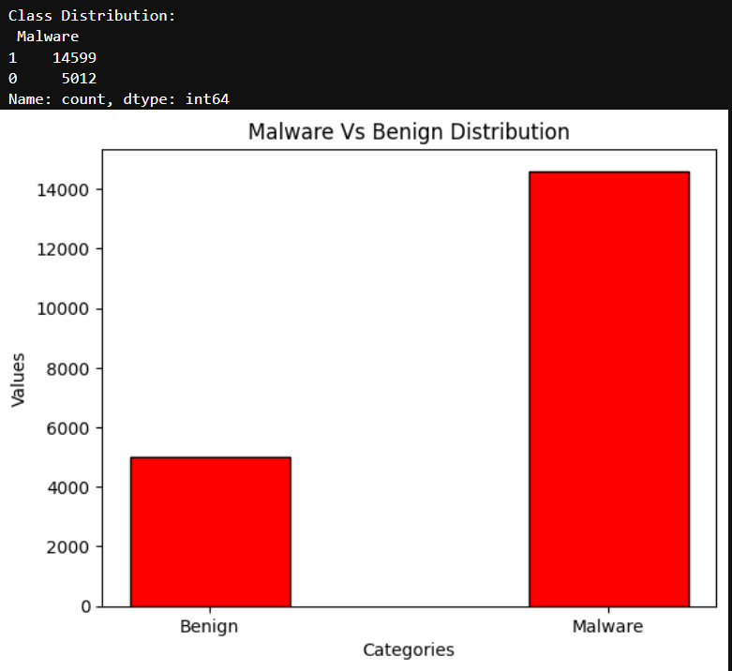

Test 2 : Missing Features
#Missing Values Check
missing_values = df.isnull().sum()
print("Missing Values in Each Column:\n", missing_values[missing_values > 0])

OUTPUT:
Missing Values in Each Column:
Series([], dtype: int64)

Test 3 : Missing Features
#Categorical columns can be of type object or category hence look for columns with this type
categorical_columns = df.select_dtypes(include=['object', 'category']).columns
print("Categorical Columns:\n", categorical_columns)

OUTPUT:
Categorical Columns:
Index(['Name'], dtype='object')

Test 4 : Unique columns
# Get columns with unique values in each row
unique_columns = [col for col in df.columns if df[col].nunique() == len(df)]
print("Columns with Unique Values:\n", unique_columns)

OUTPUT:
Columns with Unique Values:
['Name']

Test 5 : Features irrelevance & Test 6 : Unextractable features
# Manual Check

Analysis Conclusion
- Test 1 :
  - Imbalance is present in target column
  - Malware class vastly outbounds Benign class
  - Needed Adjustment: Oversampling of the minority class (Benign) is needed
- Test 2 :
  - No missing features all cells and columns are complete
  - Needed Adjustment : None
- Test 3 and Test 4 :
  - Categorical column is ‘Name’
  - However, ‘Name’ column is has 19611 unique values therefor does not contribute to overall learning
  - Needed Adjustment : Drop name column while training

- Test 5 :
  - TimeDateStamp does not provide useful insights of file classification
  - Malware classification often focuses on the static characteristics of files (e.g., header information, byte patterns)
  - Needed Adjustment : Drop TimeDateStamp column
- Test 6 :
  - “Machine” column is having two values only 332 repeated 17,009 and 34.4k 2602 times
  - This feature is unextractable from file signature
  - Needed Adjustment : Drop Machine column
- Final Requirements :
  - used_features = df.drop(['Name', 'Machine', 'TimeDateStamp', 'Malware'], axis=1)
  - Number of used features : 79 – 4 = 75
  - Oversampling of Benign class

Oversampling of Benign class
import pandas as pd
from sklearn.utils import resample
from sklearn.model_selection import train_test_split

df = pd.read_csv('dataset_malwares.csv');

benign = df[df['Malware'] == 0]
malicious = df[df['Malware'] == 1]
# Oversample benign instances
benign_oversampled = resample(benign,replace=True,n_samples=len(malicious),random_state=42)

# Combine oversampled benign with original malicious
df_oversampled = pd.concat([benign_oversampled, malicious])

used_features = df_oversampled.drop(['Name', 'Machine', 'TimeDateStamp', 'Malware'], axis=1)
X_train, X_test, y_train, y_test = train_test_split(used_features , df_oversampled['Malware'] , test_size=0.20, random_state=42);

Histogram Distribution Oversampling

Before :
After :

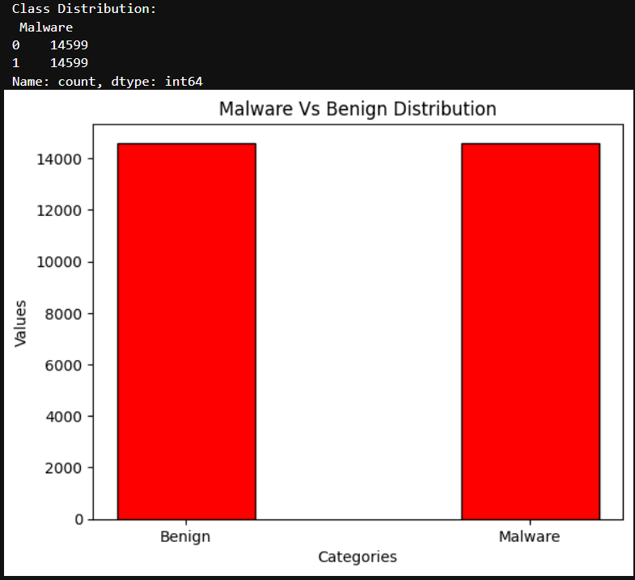

Models used
- Model 1 : Random Forest : builds multiple decision trees during training and outputs the class which is mode of the classes of individual trees
- Model 2 : Logistic Regression : is a linear model used for binary classification that estimates the probability of a binary outcome.
- Model 3 : Gradient Boosting : builds models sequentially improves the model’s performance by focusing on the residuals (errors)

Building Classifier Model
As our team practice best approach in Machine learning our team decided to use 3 models in classification process. Afterwards we use a structured approach to help select best model for our classification task

Independent variables
- Independent variables must be kept constant across all models created:
  - Same dataset csv file “dataset_malwares.csv”
  - random_state =42 ensure all models receive same training and testing data
  - test_size = 0.20 ensures testing is 20% of dataset and remains consist with all models
  - Training : Test ratio = 80:20
  - n_samples=len(malicious) ensures benign oversampling is same across all models
  - Afterall Independent code section must be constant

Independent Code :
#independent (Independent)
import pandas as pd
from sklearn.utils import resample
from sklearn.model_selection import train_test_split
df = pd.read_csv('dataset_malwares.csv');

benign = df[df['Malware'] == 0]
malicious = df[df['Malware'] == 1]
# Oversample benign instances
benign_oversampled = resample(benign,replace=True,n_samples=len(malicious),random_state=42)

# Combine oversampled benign with original malicious
df_oversampled = pd.concat([benign_oversampled, malicious])
class_distribution = df_oversampled['Malware'].value_counts()
#print("Class Distribution:\n", class_distribution) OUTPUTS 14599 for both classes
used_features = df_oversampled.drop(['Name', 'Machine', 'TimeDateStamp', 'Malware'], axis=1)

X_train, X_test, y_train, y_test = train_test_split(used_features , df_oversampled['Malware'] , test_size=0.20, random_state=42);

Training : Test ratio
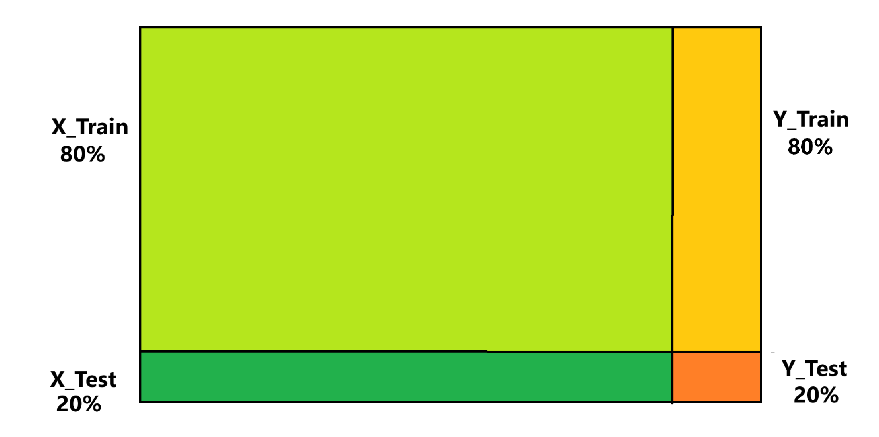

Model 1 : Random Forest

Training
from sklearn.ensemble import RandomForestClassifier
rf = RandomForestClassifier(n_estimators=100, random_state=17);
rf.fit(X_train, y_train);
Note : Chosen baseline for number of trees in RF is 100

Testing
# Make predictions on the test set
y_pred = rf.predict(X_test)

Evaluation Metrics
# Evaluate the performance
accuracy = accuracy_score(y_test, y_pred)
print(f"Accuracy: {accuracy * 100:.2f}%")

print(classification_report(y_test, y_pred, target_names=['Benign', 'Malware']))
cm = confusion_matrix(y_test, y_pred)

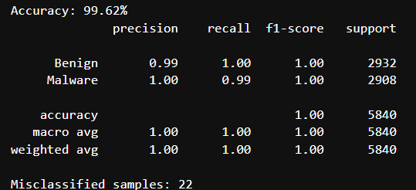

Metrics Explained
The output from classification_report function provided by sklearn provides a summary of the performance of a binary classifier, with metrics for each class (Benign and Malware) along with overall metrics.Note classification_report Function rounds up
- Accuracy : 99.52%
  - Accuracy of 0.9952 indicates that 99% of the instances in the test set were correctly classified as either "Benign" or "Malware."

Classification Report
 | Precision | Recall | F1-Score | Support
Benign | 0.99 | 1 | 1 | 2932
Malware | 1 | 0.99 | 1 | 2908
Accuracy |  |  | 1 | 5840
Macro Avg | 1 | 1 | 1 | 5840
Weighted Avg | 1 | 1 | 1 | 5840

  - Precision :
    - Shows accuracy of the positive predictions for each class
    - Overall Precision indicates the model’s accuracy in identifying true positives across all classes
    - Benign : 99% of the instances predicted as "Benign" were benign
    - Malware : 100% of instances predicted as “Malware” were benign
    - Overall Precision ( Weighted Avg Precision): 1.00
    - Conclusion : This shows that model avoids false positives on average across both classes (Benign and Malware).
  - Recall
    - Ability to find all relevant instances of each class (true positives)
    - Benign : 100% means the model correctly identified 100% of the benign cases
    - Malware : 100% means it identified 100% of the malware cases in the test data
    - Overall Recall ( Weighted Avg Precision): 1.00
    - Conclusion : Shows model is highly successful at correctly identifying both Benign and Malware samples.
  - F1 Score
    - Harmonic mean of precision and recall
    - Benign : 100%
    - Malware : 100%
    - Overall F1 score ( weighted average F1 score) : 1.00
    - Conclusion : This high F1 score indicates that the model is exceptionally reliable in correctly classifying both classes , while keeping false positives and false negatives to a minimum

  - Support
    - Support shows the actual number of instances for each class in the test set.
    - Here, there are 2932 benign cases and 2908 malware cases.

Confusion matrix
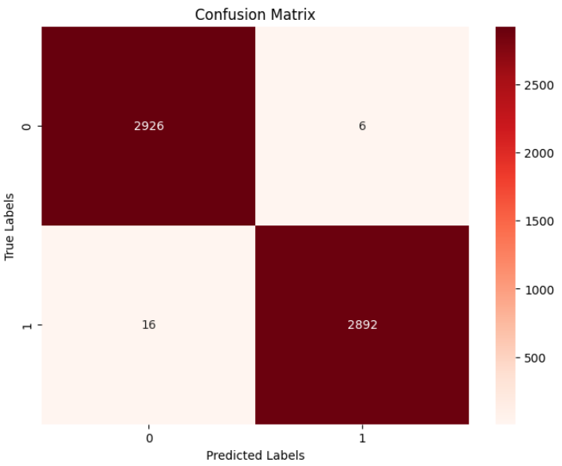
Breakdown of the Confusion Matrix:
- 0 represents the "Benign" class (non-malware).
- 1 represents the "Malware" class.
- True Positives (TP): 2892
  - The number of "Malware" instances correctly classified as "Malware"
- True Negatives (TN): 2926
  - The number of "Benign" instances correctly classified as "Benign"
- False Positives (FP): 6
  - The number of "Benign" instances incorrectly classified as "Malware"
- False Negatives (FN): 16
  - The number of "Malware" instances incorrectly classified as "Benign"

Misclassification
Misclassification is known as the total False Positives + False Negatives
This matches the confusion matrix 16 + 6
misclassified = np.where(y_test != y_pred)[0]
print(f"Misclassified samples: {len(misclassified)}")

OUTPUT : 22

Cross-Validation Scores
The K-Fold cross validation ensures all data is used as training and testing
- Report the cross-validation results, including mean accuracy and standard deviation.
- To choose value for K :
  - K determines how to split the dataset
  - The dataset is divided into k equally sized subsets or "folds"
Choosing K :
for n in range(2,11):
print( f'19611/{n} : {19611/n}')

OUTPUT
19611/2 : 9805.5
19611/3 : 6537.0
19611/4 : 4902.75
19611/5 : 3922.2
19611/6 : 3268.5
19611/7 : 2801.5714285714284
19611/8 : 2451.375
19611/9 : 2179.0
19611/10 : 1961.1

Therefor our team decided to use k = 9 as it divides dataset equally
K = 3 is not chosen as it is smaller than minimum K (k = 5)

- Number of Training times = 9
- Each Time
  - Number of Training Folds = 8
  - Number of Testing Folds = 1
- Each Fold
  - Used 8 times as training
  - Used 1 time as testing

#K-Fold Cross validation
from sklearn.model_selection import cross_val_score
X = df.drop(['Name', 'Machine', 'TimeDateStamp', 'Malware'] , axis = 1)
y = df['Malware']
k = 9 #Folds
scores = cross_val_score(rf, X, y, cv=k, scoring='accuracy')

print("Cross-Validation Scores for each fold:", scores)
print("Mean Accuracy:", scores.mean())
print("Standard Deviation:", scores.std())

OUTPUT
Cross-Validation Scores for each fold: [
0.98990363 0.99449289
0.99541074 0.99173933
0.99403396 0.9912804
0.98806792 0.99357503
0.99082148]
Mean Accuracy: 0.9921472642904491
Standard Deviation: 0.0022632544002011497

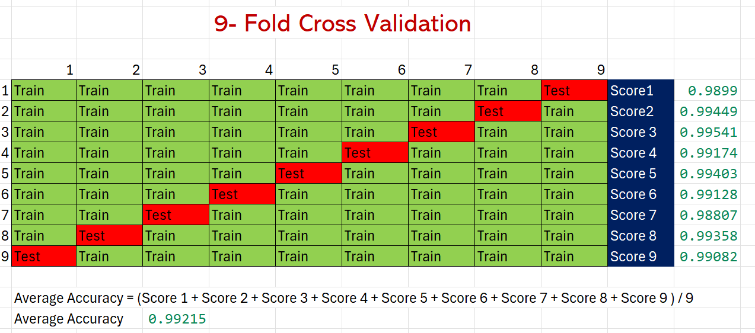
- Mean Accuracy: 0.9921472642904491
  - This means , on average, our team model achieved an accuracy of approximately 99.21% across all the folds.
- Standard Deviation: 0.0022632544002011497
  - This means that our model accuracy scores are quite consistent. As the standard deviation is small compared to the mean accuracy.

Model 2 : Logistic Regression

Training
from sklearn.linear_model import LogisticRegression;
classifier = LogisticRegression( solver='liblinear',max_iter=3000);
classifier.fit( X_train,y_train);

Testing
y_pred = classifier.predict(X_test);

Misclassifications = FP + FN = 2877 + 1 = 2878

Evaluation Matrices
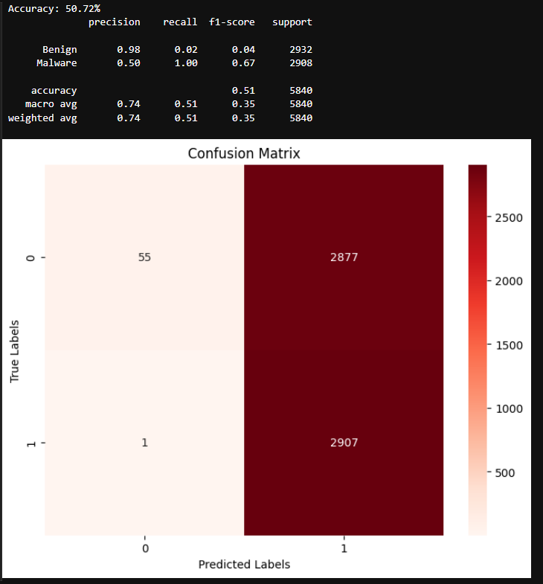

Model 3 : Gradient Boosting

Training
from sklearn.ensemble import GradientBoostingClassifier
model = GradientBoostingClassifier(n_estimators=100, learning_rate=0.1, max_depth=3, random_state=42)
model.fit(X_train, y_train)

Testing
# Make predictions
y_pred = model.predict(X_test)

Evaluation Matrices
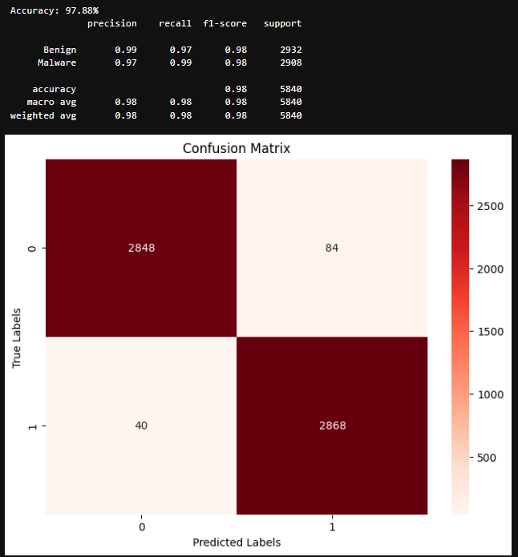

Matrix Comparison

Model | Accuracy | Precision (Benign) | Recall (Benign) | F1-Score (Benign) | Precision (Malware) | Recall (Malware) | F1-Score (Malware) | Macro Avg F1 | Weighted Avg F1
Gradient Boosting | 97.88% | 0.99 | 0.97 | 0.98 | 0.97 | 0.99 | 0.98 | 0.98 | 0.98
Logistic Regression | 50.72% | 0.98 | 0.02 | 0.04 | 0.50 | 1.00 | 0.67 | 0.35 | 0.35
Random Forest | 99.52% | 0.99 | 1.00 | 1.00 | 1.00 | 0.99 | 1.00 | 1.00 | 1.00

Misclassifications Comparison (FN+FP)
Gradient Boosting | 84 + 40 = 124
Logistic Regression | 2877 + 1 = 2878
Random Forest | 16 + 6 = 22

Model Computational Power
In this section we measure runtime and memory usage of each model
The logic we take to measure the run time and memory usage

Measuring Runtime
Training Time:
- time.time() captures the current time in seconds
- Difference between the two times equals total time taken to train the model.
start_train_time = time.time()
model.fit(X_train, y_train)
end_train_time = time.time()
train_time = end_train_time - start_train_time

Inference Time:
- Also known as time to make prediction
- time.time() difference gives the inference time
start_pred_time = time.time()
y_pred = model.predict(X_test)
end_pred_time = time.time()
inference_time = end_pred_time - start_pred_time

Measuring Memory Usage
Tools used : psutil and memory_profiler:
Initial Memory Check (Before Training):
- psutil.virtual_memory().used captures the amount of memory currently being used by the system in bytes
- This is done before training
mem_before = psutil.virtual_memory().used / (1024 ** 2) # Memory in MB

Memory After Training and prediction:
mem_after = psutil.virtual_memory().used / (1024 ** 2) # Memory in MB
Memory Consumption:
- The difference between mem_after and mem_before tells memry consumed when training
memory_consumption = mem_after - mem_before

Random Forest
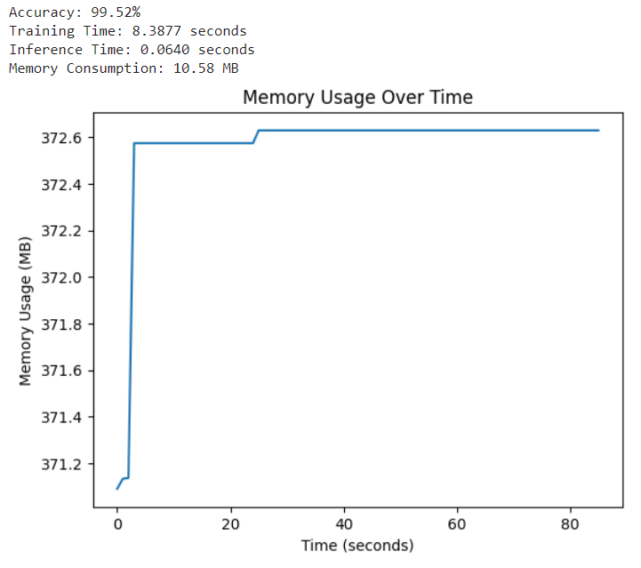

Logistic regression
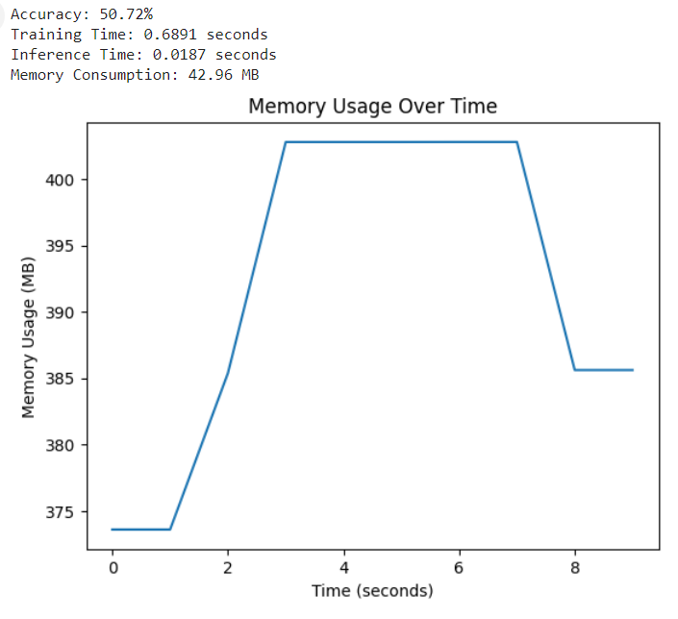

Gradient Boosting
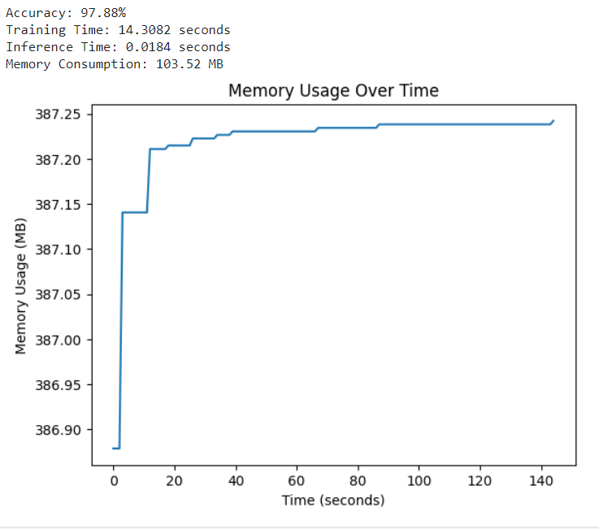

Report Conclusion
Wining model : Random Forest Model
Our Team selects Random Forest Model as the best model used for malware detection as it performs best at all evaluation matrix
- Highest Accuracy: Random Forest achieves an accuracy of 99.52%, outperforming Gradient Boosting (97.88%) and Logistic Regression (50.72%).
- Precision, Recall, and F1-Score: For both benign and malware classes, Random Forest has nearly perfect precision, recall, and F1-scores (all close to or exactly 1.00), indicating that it accurately classifies both classes with minimal errors.
- Balanced Performance: Both the macro and weighted averages of F1-scores are 1.00, showing that Random Forest consistently handles class imbalances and achieves near-perfect results.
- Mis-classifications : Random Forest has lowest sum of FP and FN
- Memory and Training time : For the given malware classification Randon forest has optimal balance between memory and training time for the following

References
- jooarajocosta (2023). notebookc98a55f5d5. [online] Kaggle.com. Available at: https://www.kaggle.com/code/jooarajocosta/notebookc98a55f5d5 [Accessed 8 Nov. 2024].
- GeeksforGeeks (2018). ML | Handling Missing Values. [online] GeeksforGeeks. Available at: https://www.geeksforgeeks.org/ml-handling-missing-values/.
- ‌Mondal, D. (2023). Imbalanced data classification: Oversampling and Undersampling. [online] Medium. Available at: https://medium.com/@debspeaks/imbalanced-data-classification-oversampling-and-undersampling-297ba21fbd7c
- Donges, N. (2021). Random Forest: a Complete Guide for Machine Learning. [online] Built in. Available at: https://builtin.com/data-science/random-forest-algorithm.
- Belyadi, H. and Haghighat, A. (2021). Supervised learning. Machine Learning Guide for Oil and Gas Using Python, pp.169–295. doi:https://doi.org/10.1016/b978-0-12-821929-4.00004-4.
- ‌GeeksforGeeks. (2021). Monitoring memory usage of a running Python program. [online] Available at: https://www.geeksforgeeks.org/monitoring-memory-usage-of-a-running-python-program/.

